Cedar Crest Kennel

Puppy Guarantee

SELLER REPRESENTATIONS AND LIMITED WARRANTY
The Seller represents:
(a) the puppy being sold has been examined by a licensed Veterinarian and was found
to be in good health; and
(b) reasonable precautions have been taken to prevent this puppy from acquiring
hereditary defects of the hips, eyes, and heart.

Hip Dysplasia, Elbows, Eyes and/or Heart(24 Month Guarantee):
Seller hereby warrants only the following:
Should the animal purchased under this agreement be diagnosed by a board certified
specialist as being affected by hereditary defects of the hips, elbows, eyes and/or heart, the
Seller will at their discretion take the puppy back and replace it with a puppy from
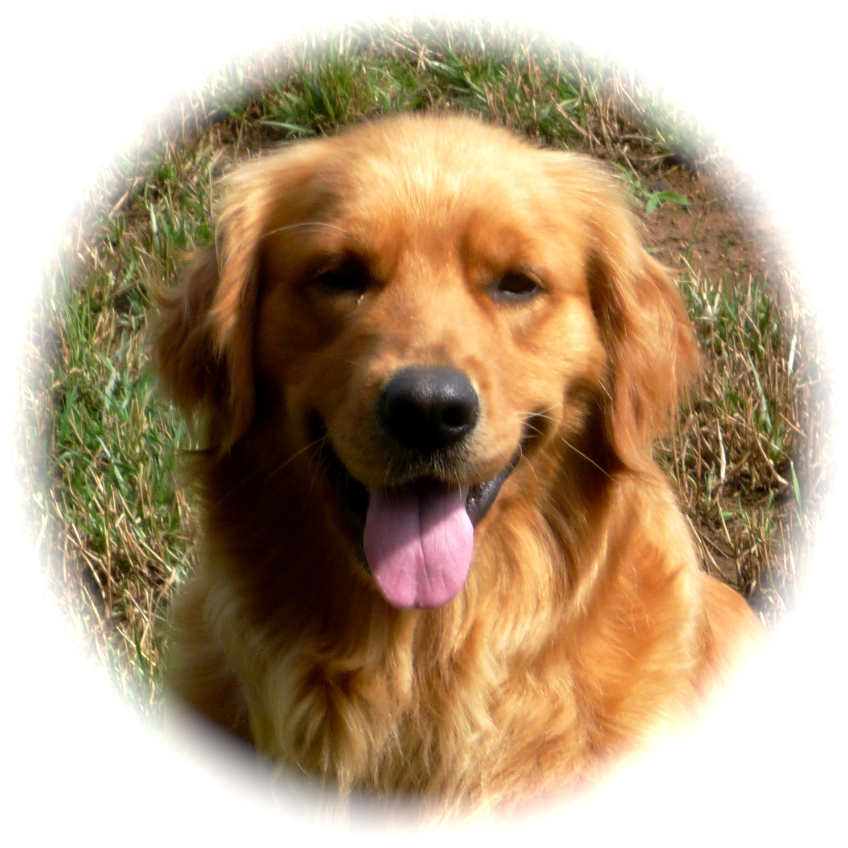
another breeding of equal value and may be any sex specified by you, so long as said diagnoses and request for replacement occur within two (2) years of the animal’s birth date for any purchased animal suffering a hereditary defect(s) of the hip(s) and within one(1) year of the animal’s birth date for any hereditary defect(s) of the eyes, heart, and/or elbow(s). If you receive a replacement, you have the choice to keep your original Golden or return him/her to us.

If you or your veterinarian suspect Hip Dysplasia, you must carefully follow these instructions:
- Have your vet take an OFA quality radiograph of the joint(s) in question. We along with the OFA require that all x-rays be identified with the following information: Name, AKC number, microchip ID number, date of x-ray.
- Have your vet submit the radiograph with appropriate fees to the OFA, 2300 Nifong Blvd., Columbia, MO 65210-3856.
- Notify me by phone.
- Once the OFA report arrives, send me your copy for verification. You may also need to furnish us with any past and current medical records on your pet to rule out environmental causes if they are suspected.

Stipulations to Hip Dysplasia Guarantee:
- The dog must be spayed or neutered within 30 days of being diagnosed with any heritable disease if you plan to keep him/her. If returning the dog, we require the dog be returned to us within 30 days of being diagnosed.
- AKC papers must be registered in your name and must contain the Cedar Crest prefix as part of the dog’s registered name. Proof of such must be sent to us immediately.
- If you elect to return the dog to us, then we require the following documents prior to the dog being returned: signed AKC papers, all medical records, current rabies and vaccination certificates.

This guarantee becomes void if:
- the dog is female and was bred prior to two years of age;
- the dog was bred though AKC papers are marked “Limited Registration” regardless of age or sex;
- the dog was bred prior to any OFA/CERF certifications or preliminary evaluations;
- OFA and/or veterinary statements are dated after the 24 month time period;
- the dog is severely overweight and/or has suffered from any accident or injuries to the affected joint(s); and
- the dog’s original microchip implanted by Cedar Crest was removed or replaced without our consent.

Heritable Eye Diseases(12-Month Guarantee)
This puppy is guaranteed free of the following heritable eye diseases prevalent within the Golden breed. Progressive Retinal Atrophy (PRA), Entropion and Cataracts. Diagnoses of any of these heritable eye diseases must be made by an American College of Veterinary Ophthamologist (ACVO). If the dog is diagnosed by an (AVCO) vet with any eye defect named above, then we will offer you a replacement puppy from any planned or future litters at Cedar Crest based on your preference. Replacement puppies are of equal value and may be any sex specified by you. Replacement puppies are not to be sold by you for compensation purposes. If you receive a replacement, you have the choice to keep your original Golden or return him/her to us.

Stipulations to Eye Guarantee:
- The dog must be spayed or neutered within 30 days of being diagnosed with any heritable eye disease if you plan to keep him/her. If returning the dog, we require the dog be returned to us within 30 days of being diagnosed.
- AKC papers must be registered in your name and must contain the Cedar Crest prefix as part of the dog’s registered name. Proof of such must be sent to us immediately.
- If you elect to return the dog to us, then we require the following documents prior to the dog being returned: signed AKC papers, all medical records, current rabies and vaccination certificates.

Buyer(s) understand(s) that the eventual personality and/ traits of the dog purchased cannot be guaranteed. As such, and knowing that any disparaging remarks against Cedar Crest Kennel will result in irreparable harm to Cedar Crest Kennel and its business, Buyer(s) agree(s) to refrain from making any disparaging remarks or comments, publicly or privately, concerning Cedar Crest Kennel or the dogs bred at Cedar Crest Kennel.

General Health(3 Day Guarantee)
The purchased puppy will be examined by a licensed Veterinarian within 72
hours of receipt. Proof of examination within 72 hours of receipt shall be provided to
Seller, at Seller’s request, should Buyer(s) request any adjustment of price or seek an
exchange. If the puppy is returned due to illness (other than a hereditary defect(s) as stated
in Seller’s guarantee, above), a verified letter specifically addressing the purported
illness is required from the veterinarian. This includes death or illness from any health
condition deemed present prior to removal from Cedar Crest Kennel’s premises.
The puppy is guaranteed to be in good health at the time it leaves Cedar Crest Kennel. If your puppy becomes ill within 3 days from the time you received it, you most call me immediately.
Do NOT return a sick puppy to this Kennel without our permission. If your puppy develops a communicable disease within 3 days of leaving here, we must quarantine any remaining puppies to see if any symptoms develop. If no puppy here develops any symptoms, then we deem it highly likely the illness was picked up after the puppy left here. We have no control of elements the puppy may be exposed to once he/she leaves our Kennel. Please be responsible and keep your puppy isolated from other dogs or places where other dogs have been until all puppy boosters are up to date. When you take the puppy to your vet for a physical examination within 72 hours of the purchase or airline arrival time and your vet deems this puppy unsound in physical health, we will issue you a full refund of the purchase price upon receipt of proper documentation from your vet. If you live outside the state of Tennessee, we require the vet’s statement be faxed to us and it must show the attending vet’s name and phone number in order for verbal verification on the dog’s health status to be attained.

Medical Care and Treatment.
Buyer(s) further agree(s), as part of Buyer’s performance under this Guarantee, the purchased animal will be given proper medical care including, but not limited to, vaccinations, annual boosters, regular de-worming, adequate and proper shade, and housing in a fenced yard or kennel. Buyer(s) agrees that he/she will feed,water, exercise, groom, train and care for this dog in a manner consistent with high quality animal practices and those endorsed by the Breeder and the AKC.

Costs of All Returns.
Buyer(s) agree(s) that, should an animal purchased under this Guarantee be returned for any reasons, Buyer(s) accepts responsibility for and shall pay, without recourse against the Seller, any and all transportation expenses, veterinary charges, crate fees, air freight charges, and transport fees to and from involved airports. Should an exchange animal be agreed upon, Buyer(s) shall be responsible for any and all costs, charges, and/or fees associated with transportation of the
exchange animal. The seller is not responsible or liable for any medical expenses acquired due to office visits, routine check-ups, vaccinations, deworming, elective procedures such as spaying, neutering, euthanasia, x-ray or OFA/CERF fees or any other special consulting fees. Any and all other costs accrued are the sole responsibility of the purchaser.

